**Windows 2000**

**Windows 2000** is a line of operating systems produced by Microsoft for use on business desktops, notebook computers, and servers. Released on 17 February 2000, it was the successor to Windows NT 4.0, and is the final release of Microsoft Windows to display the "Windows NT" designation. It was succeeded by Windows XP for desktop systems in October 2001 and Windows Server 2003 for servers in April 2003.

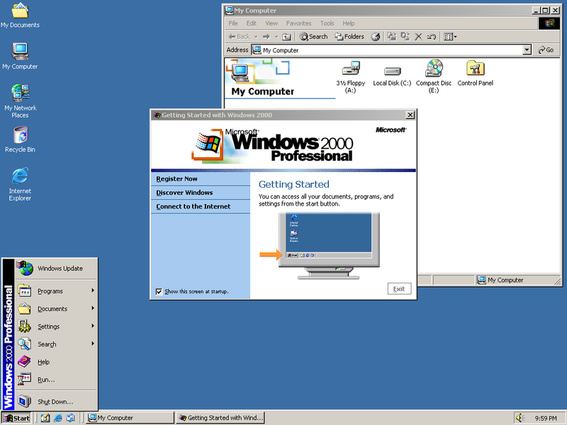Four editions of Windows 2000 were released: *Professional*, *Server*, *Advanced Server*, and *Datacenter Server*. Additionally, Microsoft sold Windows 2000 *Advanced Server Limited Edition* and Windows 2000 *Datacenter Server Limited Edition*, which were released in 2001 and run on 64-bit Intel Itanium microprocessors. While each edition of Windows 2000 was targeted to a different market, they share a core set of features, including many system utilities such as the Microsoft Management Console and standard system administration applications. Support for people with disabilities has been improved over Windows NT 4.0 with a number of new assistive technologies, and Microsoft increased support for different languages and locale information. All versions of the operating system support the Windows NT file system, NTFS 3.0, the Encrypting File System, as well as basic and dynamic disk storage. The Windows 2000 Server family has additional features, including the ability to provide Active Directory services (a hierarchical framework of resources), Distributed File System (a file system that supports sharing of files) and fault-redundant storage volumes. Windows 2000 can be installed through either a manual or unattended installation. Unattended installations rely on the use of answer files to fill in installation information, and can be performed through a bootable CD using Microsoft Systems Management Server, by the System Preparation Tool.

Microsoft marketed Windows 2000 as the most secure Windows version ever, but it became the target of a number of high-profile virus attacks such as Code Red and Nimda. Over ten years after its release, it continues to receive patches for security vulnerabilities nearly every month and will continue to do so until 13 July 2010.

**Features of Windows 2000**

**Windows Explorer**

Windows Explorer has been enhanced in several ways in Windows 2000. It is the first Windows NT release to include Active Desktop, first introduced as a part of Internet Explorer 4.0 (specifically Windows Desktop Update), and only pre-installed in Windows 98 by that time. It allowed users to customize the way folders look and behave by using HTML templates, having the file extension HTT. This feature was abused by computer viruses that employed malicious scripts, Java applets, or ActiveX controls in folder template files as their infection vector. Two such viruses are VBS/Roor-C and VBS.Redlof.a.

The right pane of Windows 2000 Explorer, which usually just lists files and folders, can also be customized. For example, the contents of the system folders aren't displayed by default, instead showing in the right pane a warning to the user that modifying the contents of the system folders could harm their computer. It's possible to define additional Explorer panes by using DIV elements in folder template files Other Explorer UI elements that can be customized include columns in "Details" view, icon overlays, and search providers: the new DHTML-based search pane is integrated into Windows 2000 Explorer, unlike the separate search dialog found in all previous Explorer versions. This degree of customizability is new to Windows 2000; neither Windows 98 nor the Desktop Update could provide it. The Indexing Services has also been integrated into the operating system and the search pane built into Explorer allows searching files indexed by its database.

**NTFS 3.0**

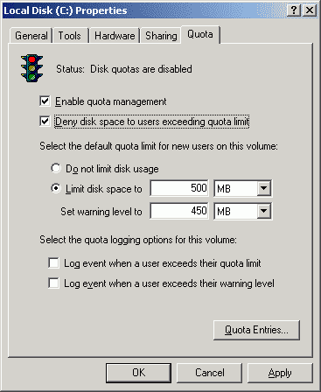

Microsoft released the version 3.0 of NTFS (sometimes incorrectly called NTFS 5 in relation to the kernel version number) as part of Windows 2000; this introduced disk quotas (provided by [QuotaAdvisor](http://en.wikipedia.org/w/index.php?title=QuotaAdvisor&action=edit&redlink=1)), file-system-level encryption, sparse files and reparse points. Sparse files allow for the efficient storage of data sets that are very large yet contain many areas that only have zeros. Reparse points allow the object manager to reset a file namespace lookup and let file system drivers implement changed functionality in a transparent manner. Reparse points are used to implement volume mount points, junctions, Hierarchical Storage Management, Native Structured Storage and Single Instance Storage. Volume mount points and directory junctions allow for a file to be transparently referred from one file or directory location to another.

**Encrypting File System**

The Encrypting File System (EFS) introduced strong file system-level encryption to Windows. It allows any folder or drive on an NTFS volume to be encrypted transparently by the user. EFS works together with the EFS service, Microsoft's CryptoAPI and the EFS File System Runtime Library (FSRTL). To date, its encryption has not been compromised.

EFS works by encrypting a file with a bulk symmetric key (also known as the File Encryption Key, or FEK), which is used because it takes less time to encrypt and decrypt large amounts of data than if an asymmetric key cipher were used. The symmetric key used to encrypt the file is then encrypted with a public key associated with the user who encrypted the file, and this encrypted data is stored in the header of the encrypted file. To decrypt the file, the file system uses the private key of the user to decrypt the symmetric key stored in the file header. It then uses the symmetric key to decrypt the file. Because this is done at the file system level, it is transparent to the user.

For a user losing access to their key, support for recovery agents that can decrypt files is built in to EFS. A Recovery Agent is a user who is authorized by a public key recovery certificate to decrypt files belonging to other users using a special *private key*. By default, local administrators are *recovery agents* however they can be customized using Group Policy.

**System Utilities**

Windows 2000 introduced the Microsoft Management Console (MMC), which is used to create, save, and open administrative tools. Each of these is called a *console*, and most allow an administrator to administer other Windows 2000 computers from one centralised computer. Each console can contain one or many specific administrative tools, called *snap-ins*. These can be either standalone (with one function), or an extension (adding functions to an existing snap-in). In order to provide the ability to control what snap-ins can be seen in a console, the MMC allows consoles to be created in *author mode* or *user mode.* Author mode allows snap-ins to be added, new windows to be created, all portions of the console tree to be displayed and consoles to be saved. User mode allows consoles to be distributed with restrictions applied. User mode consoles can grant full access to the user for any change, or they can grant limited access, preventing users from adding snapins to the console though they can view multiple windows in a console. Alternatively users can be granted limited access, preventing them from adding to the console and stopping them from viewing multiple windows in a single console.

The main tools that come with Windows 2000 can be found in the *Computer Management* console (in Administrative Tools in the Control Panel). This contains the Event Viewer—a means of seeing events and the Windows equivalent of a log file, a system information utility, a backup utility, Task Scheduler and management consoles to view open shared folders and shared folder sessions, configure and manage COM+ Applications, configure Group Policy, manage all the local users and user groups, and a device manager. It contains *Disk Management* and *Removable Storage* snap-ins, a disk defragmenter as well as a performance diagnostic console, which displays graphs of system performance and configures data logs and alerts. It also contains a service configuration console, which allows users to view all installed services and to stop and start them, as well as configure what those services should do when the computer starts.

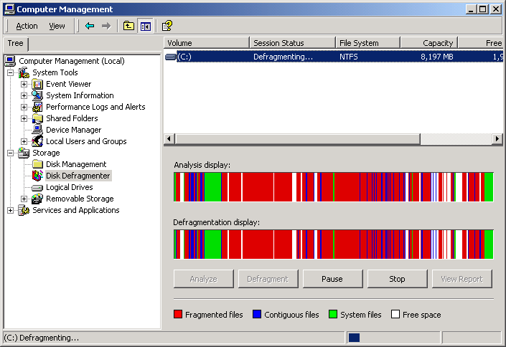Windows 2000 comes with two utilities to edit the Windows registry, *REGEDIT.EXE*  and *REGEDT32.EXE*. REGEDIT has been directly ported from Windows 98, and therefore does not support editing registry permissions. REGEDT32 has the older multiple document interface (MDI) and can edit registry permissions in the same manner that Windows NT's REGEDT32 program could. REGEDIT has a left-side tree view of the Windows registry, lists all loaded hives and represents the three components of a value (its name, type, and data) as separate columns of a table. REGEDT32 has a left-side tree view, but each hive has its own window, so the tree displays only keys and it represents values as a list of strings. REGEDIT supports right-clicking of entries in a tree view to adjust properties and other settings. REGEDT32 requires all actions to be performed from the top menu bar. Windows XP is the first system to integrate these two programs into a single utility, adopting the REGEDIT behavior with the additional NT features.

**Recovery console**

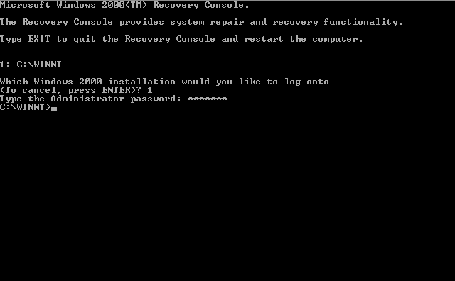The Recovery Console is run from outside the installed copy of Windows to perform maintenance tasks that can neither be run from within it nor feasibly be run from another computer or copy of Windows 2000. It is usually used to recover the system from problems that cause booting to fail, which would render other tools useless.

It has a simple command line interface, used to check and repair the hard drive(s) , repair boot information (including NTLDR) , replace corrupted system files with fresh copies from the CD, or enable/disable services and drivers for the next boot.

The console can be accessed in either of the two ways:

1. Booting from the Windows 2000 CD, and choosing to start the Recovery Console from the CD itself instead of continuing with setup. The Recovery Console is accessible as long as the installation CD is available.
2. Preinstalling the Recovery Console on the hard disk as a startup option in Boot.ini, via WinNT32.exe, with the /cmdcons switch. In this case, it can only be started as long as NTLDR can boot from the system partition.

**Distributed File System**

The Distributed File System (DFS) allows shares in multiple different locations to be logically grouped under one folder, or *DFS root*. When users try to access a network share off the DFS root, the user is really looking at a *DFS link* and the DFS server transparently redirects them to the correct file server and share. A DFS root can only exist on a Windows 2000 version that is part of the server family, and only one DFS root can exist on that server.

There can be two ways of implementing a DFS namespace on Windows 2000: either through a standalone DFS root or a domain-based DFS root. Standalone DFS allows for only DFS roots on the local computer, and thus does not use Active Directory. Domain-based DFS roots exist within Active Directory and can have their information distributed to other domain controllers within the domain — this provides fault tolerance to DFS. DFS roots that exist on a domain must be hosted on a domain controller or on a domain member server. The file and root information is replicated via the Microsoft File Replication Service (FRS).

**Editions of Windows 2000**

Microsoft released various editions of Windows 2000 for different markets and business needs: Professional, Server, Advanced Server and Datacenter Server. Each was packaged separately.

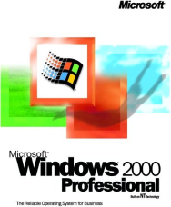**Windows 2000 Professional** was designed as the desktop operating system for businesses and power users. It is the client version of Windows 2000. It offers greater security and stability than many of the previous Windows desktop operating systems. It supports up to two processors, and can address up to 4 GB of RAM. The system requirements are a Pentium processor of 133 MHz or greater, at least 32 MB of RAM, 650 MB of hard drive space, and a CD-ROM drive (recommended:Pentium II, 128 MB of RAM, 2 GB of hard drive space, and CD-ROM drive).

**Windows 2000 Server** SKUs share the same user interface with Windows 2000 Professional, but contain additional components for the computer to perform server roles and run infrastructure and application software. A significant new component introduced in the server SKUs is Active Directory, which is an enterprise-wide directory service based on LDAP. Additionally, Microsoft 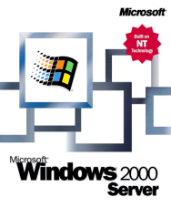integrated Kerberos network authentication, replacing the often-criticised NTLM authentication system used in previous versions. This also provided a purely transitive-trust relationship between Windows 2000 domains in a *forest* (a collection of one or more Windows 2000 domains that share a common schema, configuration, and global catalog, being linked with two-way transitive trusts). Furthermore, Windows 2000 introduced a Domain Name Server which allows dynamic registration of IP addresses. Windows 2000 Server supports up to 4 processors, requires 128 MB of RAM and 1 GB hard disk space, however requirements may be higher depending on installed components.

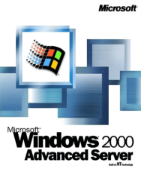**Windows 2000 Advanced Server** is a variant of Windows 2000 Server operating system designed for medium-to-large businesses. It offers clustering infrastructure for high availability and scalability of applications and services, including main memory support of up to 8 gigabytes (GB) on Physical Address Extension (PAE) systems and the ability to do 8-way SMP. It supports TCP/IP load balancing and enhanced two-node server clusters based on the Microsoft Cluster Server (MSCS) in Windows NT Server 4.0 Enterprise Edition. Limited number of copies of an IA-64 version, called Windows 2000 Advanced Server, Limited Edition were made available via OEMs. System requirements are similar to those of Windows 2000 Server, however they may need to be higher to scale to larger infrastructure.

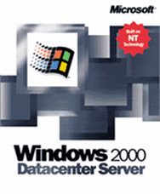**Windows 2000 Datacenter Server** is a variant of Windows 2000 Server designed for large businesses that move large quantities of confidential or sensitive data frequently via a central server. Like Advanced Server, it supports clustering, failover and load balancing. Its minimum system requirements are normal, but it was designed to be capable of handing advanced, fault-tolerant and scalable hardware—for instance computers with up to 32 CPUs and 64 GBs RAM, with rigorous system testing and qualification, hardware partitioning, coordinated maintenance and change control. Limited number of copies of an IA-64 version, called Windows 2000 Datacenter Server, Limited Edition were made available via OEMs. System requirements are similar to those of Windows 2000 Advanced Server, however they may need to be higher to scale to larger infrastructure.

**Name : Rohit Aggarwal**

**Roll No. : 7CS-097**